**Press release***Trade press*

**Kautex Maschinenbau strengthens its supply chain management**

**As of March 1, 2020, Dhanny Mulyanto joins the change team at Kautex Maschinenbau as the new Head of Global Supply Chain Management. The experienced supply chain manager will optimize the supply chain, to make it even more customer-oriented, and to ensure the availability and quality of the new products announced in the current product promotion campaign. By selecting Mulyanto, Kautex has filled another key management position.**

Mulyanto has many years experience in process and supply chain management and in-depth expertise in customer-to-customer supply processes. His most recent job was as head of supply chain management at a manufacturer of medium-voltage power-distribution substations. Kautex is currently in the middle of implementing a change process. The decisive factors in this process are a consistent focus on meeting the specific requirements of individual customers, speed, reliability and service. To ensure these requirements are met effectively, the supply chain must also be organized accordingly.

Dhanny Mulyanto is happy to take on the new challenge: "Kautex is changing and moving forward, and is a pioneer in many areas. I find the opportunity to work in this kind of environment extremely exciting and inspiring. I am pleased that I can share my knowledge and experience with the team at Kautex and will do my best to help the company progress."

Thomas Hartkämper, Kautex Maschinenbau's CEO, sees Mulyanto as support for his Change Team: "Here at Kautex, we have set ourselves ambitious goals. To achieve them, we need people who will actively drive forward the company's transformation, also in key positions. I am very happy that Dhanny Mulyanto has now joined the global management team. In particular, I value his positive attitude towards challenges and his extensive methodological expertise. Thanks to his personal knowledge of local culture and society, we will be able to build up even stronger cultural links between Kautex Germany and Kautex China."

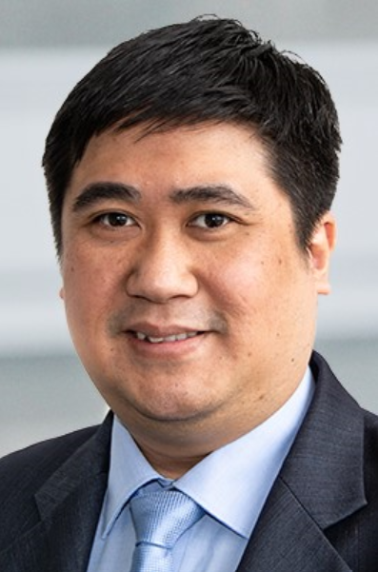

**Dhanny Mulyanto**

**About Kautex Maschinenbau**Eight decades of providing its customers with innovative products and services have turnedKautex Maschinenbau into one of the world's leading companies in extrusion blow molding technology. With customers that include major automobile manufacturers and suppliers, and as well as companies working in the packaging industry. All of them have come to rely on the knowledge and experience of a brand that stands for both quality and reliability. In addition to its HQ in Bonn, a Customer Service Center in Berlin and regional offices in the USA, Russia, China, Italy, India, Mexico and Malaysia, Kautex Maschinenbau operates an extensive global network of service and distribution offices. **Contact details**  
**Christian Kirchbaumer**  
Head of Marketing Communications

**Kautex Maschinenbau GmbH**  
Kautexstr. 54  
53229 Bonn  
Germany

T +49 228 489370

christian.kirchbaumer@kautex-group.com